Loaves & Fishes 2021 Report

December 2021
For our December dinner yesterday we had a non-stop line of guests starting at 2PM. Each guest was also given a gift card, a pair of socks, and Christmas stollen.

After serving about 110 guests --- a recent record --- we ran out of the planned menu of braised beef with mushroom. Miraculously, meals with hamburgers, tater tots and steamed vegetables quickly appeared, and none was turned away without a meal. (For comparison, we served about 70 guests for our Nov 2021 dinner, and 100 guests for Dec 2020 dinner.)

A HUGE thank you to everyone who made the December dinner a success: Debbie, Mary Spear, Marian, Rob, Samuel, Mark, Chelsea, Mason, Terence, Shane, Alden, Joe, Bill, George, Salvatore, Patrick, Su.

December 04 Volunteer List

9am to 1pm

Rob
Sam
Will
Mark
Chelsea
Mason
Kinson
Su

1pm to 530pm

Mark
Chelsea
Melissa
Alden
Kinson
Su

November Report

We served 70 guests for our Nov dinner on Sat. (We had an unusually long line of guests when we started at 2PM.) A very big thank you to everyone who made this possible: Marian, Mary Spear, Debbie, Bill, Salvatore, Rob, Samuel, Monserrat, Mark, Chelsea, Alden, Su.

November 06 Volunteer List

9am to 1pm

Rob
Will
Monserrat
Mark
Chelsea
Mason
Raymond
Kinson
Su

1pm to 530pm

Monserrat
Mark
Chelsea
Melissa
Raymond
Alden
Kinson
Su

October Report

A big thank you to everyone who made it possible: Debbie, Mary Spear, Marion, Rob, Marilyn, Monserrat, Mark, Chelsea, Alden. BTW, if anyone has not tried Rob's scones...you should :) http://www.robs-scones.com :)

Interesting stories from Sat:
* Sat AM, as Debbie was setting up decorations outside Newman, a long time guest told Debbie and I that he had been coming to L+F for over 10 years. What really stood out for L+F was that he had never become sick after eating at L+F, unlike eating at other places that serve the homeless. (This is not the first time I have heard similar comments from our guests.) Debbie --- do you recall anything else? He did return in the PM for dinner.

* Sat late PM, after everyone else has left, as I was about to lock up and leave, another long time guest showed up at the gate. Mr J --- does anyone know him (I do recognize him) --- had to commute from Fremont on that day, and was delayed by bus problems. He was really disappointed that he had missed the dinner. I offered him a croissant and a soda while I checked what we had in the freezer --- that even I could manage to cook. I found frozen hamburger patties and frozen mixed vegetables. He was not interested in hamburgers because of cholesterol problems, but really liked the bowl of frozen veg that I microwaved. He liked it so much I microwaved more of the mixed vegetables for him to take with him. In case anyone is missing the context, I am typically not allowed anywhere near the cooking in the L+F kitchen when the real chefs are around :)

October 02 Volunteer List
9am to 1pm

Rob (lead)
Will
Monserrat
Mark
Chelsea
Mason
Raymond
Kinson

1pm to 530pm (?)

Monserrat (lead)
Mark
Chelsea
Melissa
Raymond
Alden
Kinson

September Report

A very big thank you for everyone who made today's L+F dinner happen: Debbie, Marian, Mary Spear, Rob, Will, Mark, Chelsea, Mason, Monserrat, Ray, Bill, George, Salvatore.

We served 75 guests today! Some guests really liked the corn salad.

I'm not sure if Su is back from Singapore, putting her mom to rest and taking care of affairs. But, as usual, she has been orchestrating the meal - looks like tasty Labor Day fare - from the other side of the planet.

A crew of a half dozen continues to work all day to prepare it, with Marian and Mary Spear doing the shopping and Debbie doing numerous tasks (including decorating the wall at the gate). I don't forsee anything different in the near future.

Joe does a head count - with George pinch-hitting last month. I mainly hangout, occasionally shuttling prepared meals from inside.

Mostly regulars, 60 or so last month, with many hanging out a bit. JC shuttles leftovers after we close. (Full courses in bags distributed from 2 - 4:30 pm).

Sept 04 Volunteer List
9am to 1pm
Hi
Rob (lead)
Will
Monserrat
Mark
Chelsea
Mason
Kinson

1pm to 530pm (?)

Monserrat (lead)
Mark
Chelsea
Alden
Melissa
Kinson

August Report

We did it again!!! A big THANK YOU to everyone who made the August dinner possible: Terence, Debbie, Rob, Marilyn, Will, Mark, Chelsea, Raymond, Alden, Melissa, George and Bill.

Highlights:
* A guest remarked that L+F serves the best food among the organizations that serves our homeless neighbors. Bill & George, do you recall anything else the guest mentioned? BTW we DO get similar comments from our guests --- this is not the first time I have heard this. Thank you to everyone who make this happen!

* A former guest came back from WA state and decided to come by L+F again!
Su is away again tending to her mom, directing Kinson and the small dedicated skeleton crew from across the globe.

Not much to report otherwise except that the gourmet meal continues in takeout form.

I think we're in the 60-70 guests ballpark, mostly regulars. Hamid and Rick keep coming from E. Oakland as do several others. JC comes by and distributes left over meals around town.

I spoke with one of St. Mary Mag's meal volunteers a couple weeks ago who said their meals were running into the 40's. Telegraph Ave is no longer a hub - sadly, hubs and encampments stretch across town to the Bay.

Guest Feedback:
- sabrina made her first appearance in a year.
- demetrius, long time guest and now in subsidized housing, talked about how meals like, and especially, ours help him survive.
- one sandwich-only guest - remember that we used to pass out knockout bag lunches to folks who we weren't able to seat - said how much he missed the great ham and cheese sandwiches.
- a woman guest, first timer, was over the moon with the home-made 'gravy' with the veggie meal.

August 07 Volunteer List
9am to 1pm

Rob (lead)
Will
Monserrat
Mark
Chelsea
Mason
Kinson

1pm to 530pm (?)

Monserrat (lead)
Mark
Chelsea
Alden
Melissa
Kinson

July Report
A big Thank You to everyone who made this possible: the shopping crew who magically made things appear in the kitchen (Debbie, Mary Spear, Marion), and the kitchen crew who did the prep, cooking, and cleaning (Rob, Will, Mason and his parents, Mark, Chelsea, Monserrat).

July 03 Volunteer List
9am to 1pm

Rob (lead)
Will
Monserrat
Mark
Chelsea
Mason
Kinson

1pm to 530pm (?)

Monserrat (lead)
Mark
Chelsea
Alden
Melissa
Kinson

June Report

Some comments from our guests on Sat:
* Loaves and Fishes serves the best food. (BTW we do get similar comments regularly.)
* A long time guest told us she came all the way from SF for the L+F dinner. I was surprised, and she explained that it was worth the trip, for what L+F serves.
* Another guest told us she came from Richmond!

May Report

April Report

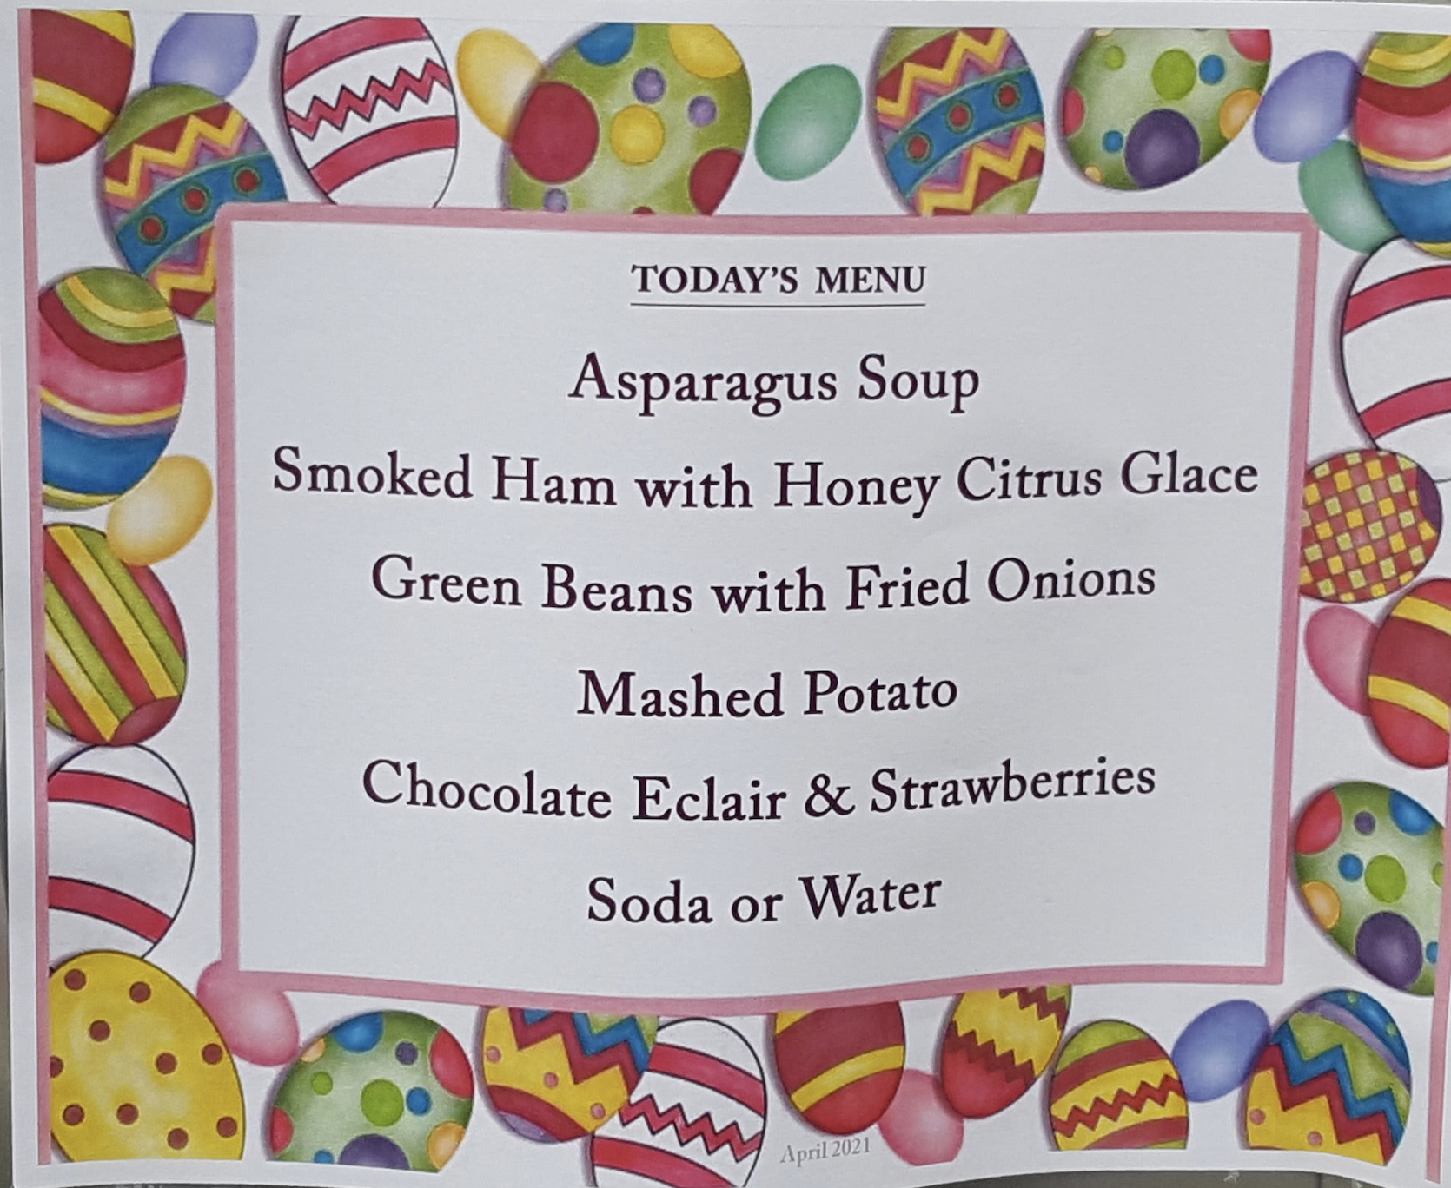

March Report

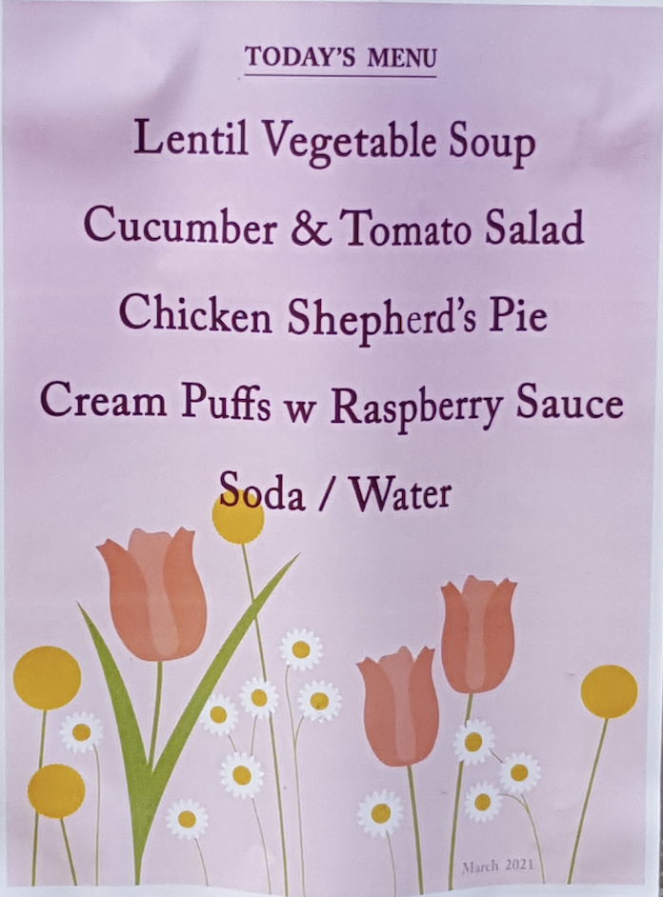

February Report

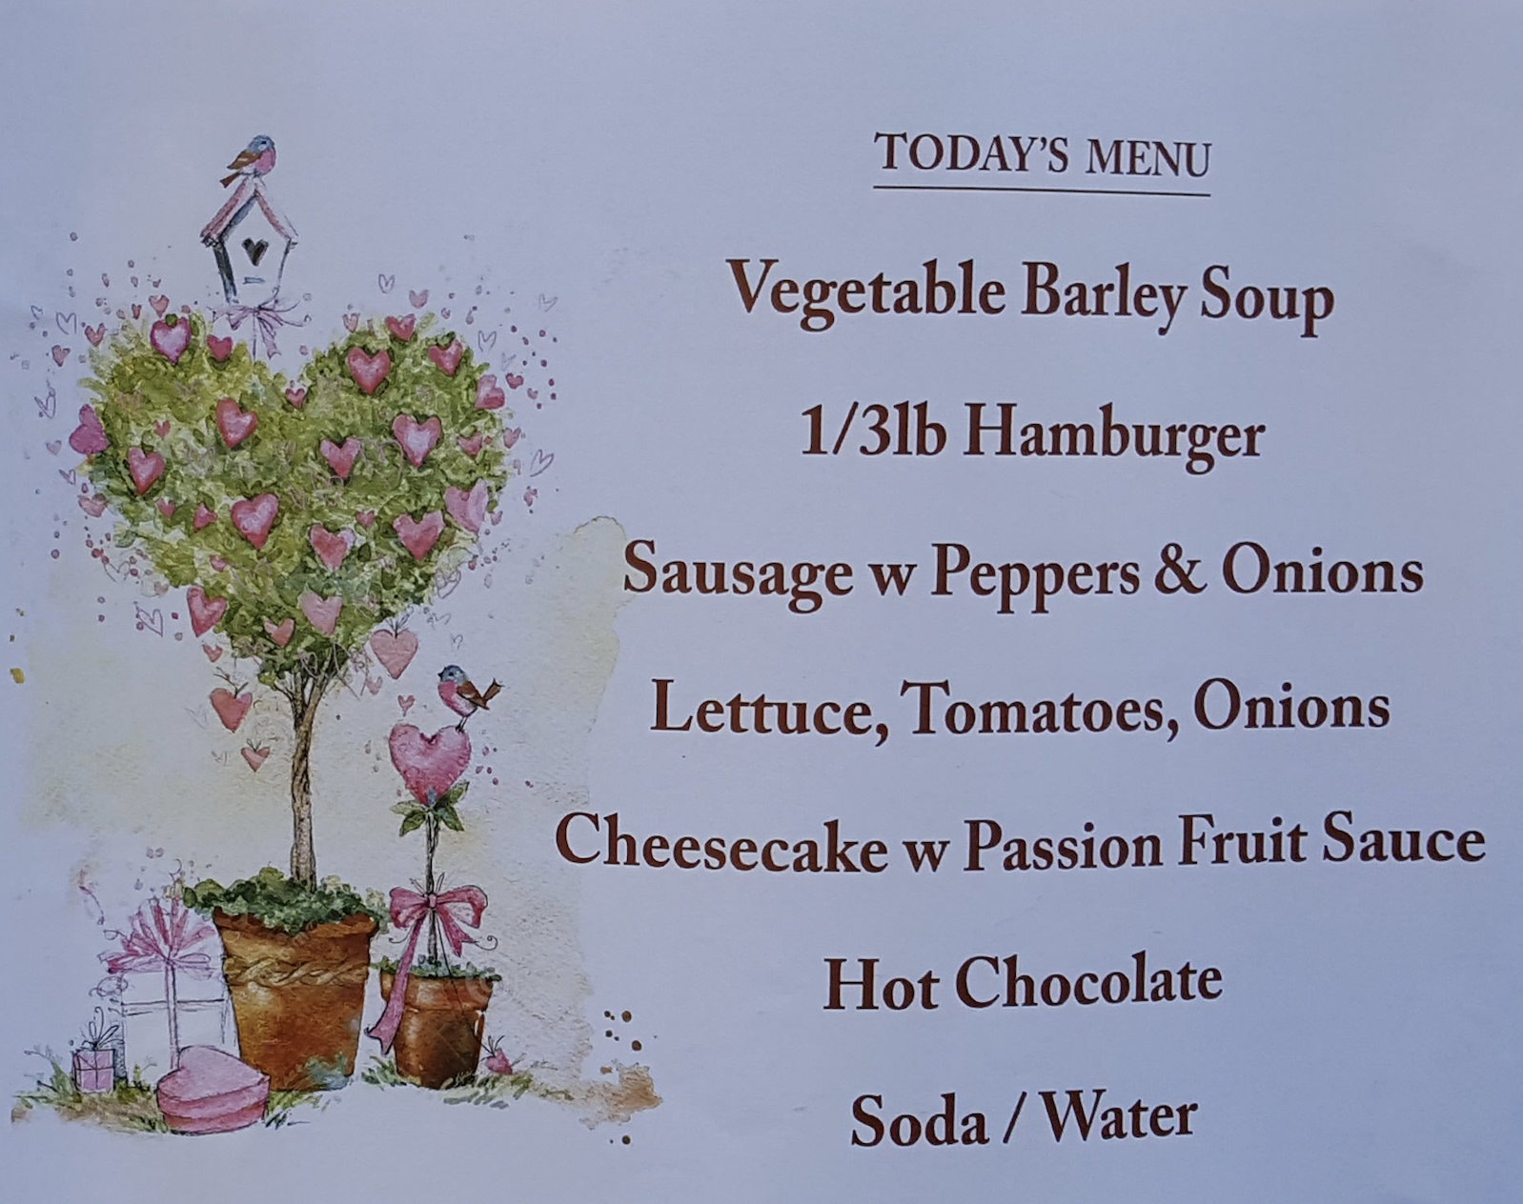

January Report

Jan 02 Volunteer List
9am to 1pm

Rob (Lead)
Will
Monserrat
Tessa
Mark
Chelsea
Mason
Kinson

1pm to 530pm (?)

Tessa (Lead)
Monserrat
Mark
Chelsea
Melissa
Kinson

